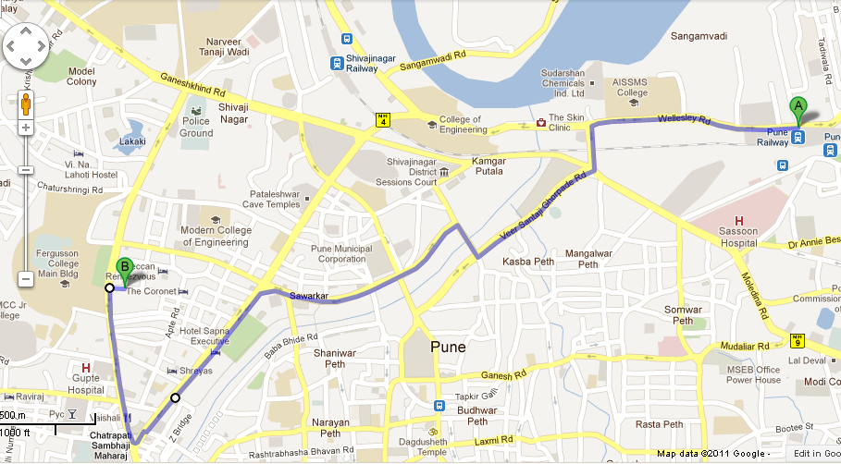
How to reach FLAME Bus stand from Pune Railway Station : The best way is to take an Auto. They run on meter and charge approx Rs 11 per kilometer. This bus stand is 6 kilometers from the railway station and is 100 meters inside the lane just opposite FC College (Fergusson College) main Gate. Once you reach there, you need to look for the bus with FLAME Logo. There are NO other signs for this bus stop. Incase you do not find the bus, then please call the FLAME travel help desk on mobile no 0 8600998503.

